Matt’s bank account balance at the end of each week for the month of October is shown in the table.
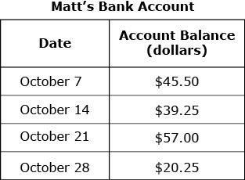
Part A
What is the mean account balance for the amounts in the table? Show your work.

Work:

Answer:
Part B
The expression below can be used to determine Matt’s take-home pay, in dollars, in one week when he works h hours.
What is the amount Matt earns when Show your work.

Work:

Answer:
Part C
Matt deposited $311.50 into his account on October 28. After he paid several bills from the account, his account balance was What was the total amount of the bills he paid that resulted in this balance? Explain your answer.
____________________________________________________________________________________________________________________________________________________________________________________________________________________________________________________________________________________________________________________________________________________________________________________________________________________________________________________________________________________

Fiona's science class used several bags of microwave popcorn for an experiment. The table of results shows the number of kernels that did not pop into popcorn from each bag.
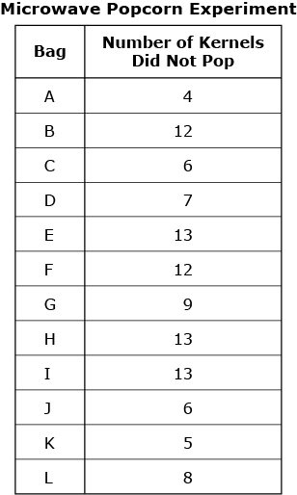
Part A
What is the interquartile range of the data? Explain your answer.
Work:
Part B
Fiona created the dot plot shown below to represent the data. Does Fiona's dot plot correctly display the data shown in the table? Explain your answer.
