Name
Drawing Polygons on a coordinate plane
Important Characteristics of Rectangles:
- Rectangles are 4 sided polygons
- They will only have 2 dimensions, length and width
- If given only one length and asked to find the missing length, they will always be equivalent!
- If given one width and asked to find the missing width, they will always be equivalent too!
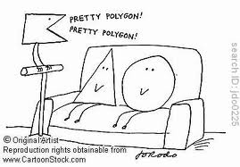
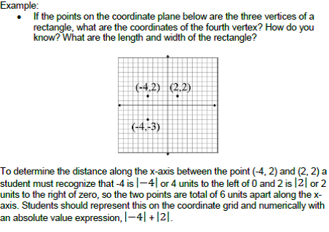
Can you finish this graph here? -->
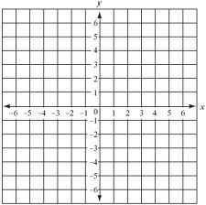
You try!
Graph the given coordinates to find the length, width, and missing ordered pair to finish the rectangle
(-3, 4), (-3, -2), (2, -2), ____________
What is the rectangle’s length?
____________________
What is the rectangle’s width?
____________________
Bonus:
What is the area of the rectangle?
____________________

Mystery Shapes

1. Graph and connect the following ordered pairs in order on the coordinate plane. Connect the last ordered pair to the first ordered pair. What shape was created?
(-3, -5), (-3, 6), (2, 6), (2, -5)
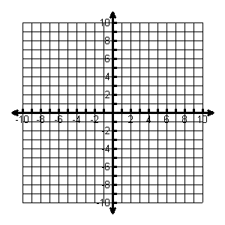
Find the perimeter of the shape: units
Find the area of the shape: square units
Which axis(es) does the shape cross? In which quadrant(s) is the shape?

2. Graph and connect the following ordered pairs in order on the coordinate plane. Connect the last ordered pair to the first ordered pair. What shape was created?
(-8, -3), (-8, 2), (-3, 2), (-3, -3)
Find the perimeter of the shape: units
Find the area of the shape: square units
Which axis(es) does the shape cross? In which quadrant(s) is the shape?

3. Graph and connect the following ordered pairs on the coordinate plane. Connect the last ordered pair to the first ordered pair. What shape was created?
(2, -3), (2, -9), (8, -9)
Find the area of the shape: square units
In which quadrant(s) is the shape?

4. Graph a rectangle with an area of 42 square units.
Name the coordinates you used: , , , Find the perimeter of the shape: units

