[](http://www.google.com/imgres?um=1&hl=en&tbo=d&biw=1600&bih=697&tbm=isch&tbnid=XOKvQvVCEQwW7M:&imgrefurl=http://www.clipartmojo.com/clip-art/girl-looking-in-mirror-1249/&docid=85S4BMJrViTe3M&imgurl=http://media.heliohosted.com/plugins/Clipart/ClipartStock1/girl%20looking%20in%20mirror.png&w=350&h=492&ei=S2zmUI73CKTi2gWYiYC4Bg&zoom=1&iact=rc&sig=118279028075191188497&page=1&tbnh=144&tbnw=102&start=0&ndsp=44&ved=1t:429,r:10,s:0,i:118&tx=63&ty=56)

Reflections on a Coordinate Plane

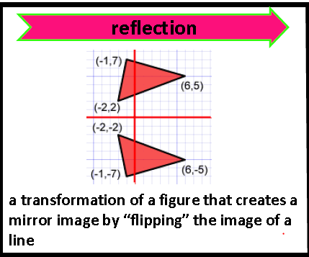

A ***reflection*** is a “mirror image” What do you notice about the

of an object that has been coordinates of the two triangles

“flipped” over an axis.

In this example, the triangle

was reflected over the x-axis.

How do you do it?

***To reflect a point, simply find the opposite.***

|  |  |
| --- | --- |
| To reflect  across the… | Do this… |
| [https://encrypted-tbn1.gstatic.com/images?q=tbn:ANd9GcTYBFbgGl208dD5oj0C-SP4cH843rd_ZAQOKUGP6KA8rAUozog9Bw](http://www.google.com/imgres?hl=en&tbo=d&biw=1600&bih=697&tbm=isch&tbnid=p80NbfJTLcN0MM:&imgrefurl=http://www.virtualnerd.com/pre-algebra/geometry/reflect-y-axis-using-graph.php?id=306&subject=pre-algebra&type=Topic&docid=QzYq3rvi3bIOuM&imgurl=http://www.virtualnerd.com/images/Tutorial/PreAlg_09_02_0029-diagram_thumb-lg.png&w=338&h=190&ei=sWPmUNmuJJCG8QTV_YGwBg&zoom=1&iact=hc&vpx=783&vpy=185&dur=624&hovh=152&hovw=270&tx=124&ty=101&sig=118279028075191188497&page=3&tbnh=139&tbnw=243&start=82&ndsp=48&ved=1t:429,r:97,s:0,i:385) | * Keep the x-coordinate the same * Find the opposite of the y-coordinate |
| https://encrypted-tbn1.gstatic.com/images?q=tbn:ANd9GcTYBFbgGl208dD5oj0C-SP4cH843rd_ZAQOKUGP6KA8rAUozog9Bw | * Keep the y-coordinate the same * Find the opposite of the x-coordinate |

**Example**: Rectangle PQRS is reflected across the y-axis. Notice the reflected points all have the

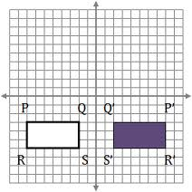 “prime” symbol. S’, or “S *prime*”, is the reflection of Point S.

1) Fill in the table with the coordinates for both rectangles.

|  |  |  |  |  |
| --- | --- | --- | --- | --- |
| P | (-8,-3) |  | P’ | (8,-3) |
| Q |  | Q’ |  |
| R |  | R’ |  |
| S |  | S’ |  |

Let’s now reflect PQRS across the x-axis.

2) Draw this reflection on the graph.

3) Label the new ordered pairs on the graph.



Reflections PRACTICE!

For each figure below, label the ordered pairs for each point. Then, reflect across the given axis. Be sure to label the ordered pairs for each point on the reflection.

**1)** Reflect rectangle ABCD across the x-axis. **2)** Reflect Δ ABC across the y-axis.

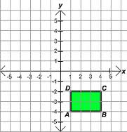 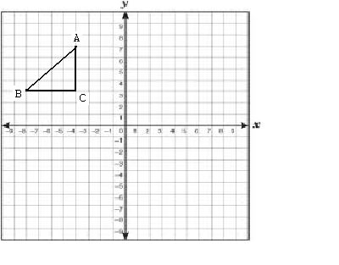

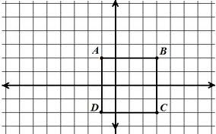

**3)** Reflect rectangle ABCD across the y-axis.

*(Don’t let the fact that it crosses the y-axis trick you!*

*You do it the same way!!)* ☺

**4)** Reflect the rectangle across the y-axis.  **5)** Reflect the trapezoid across the x-axis.

