Deion is creating a design for the back side of a T-shirt. He uses the coordinate grid shown to outline the area of the T-shirt design. Each unit represents one centimeter.
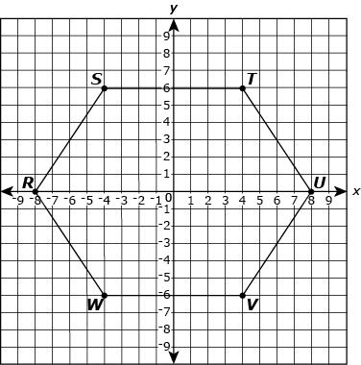
Part A
Write the coordinates for each of the points shown. Explain how you could use the coordinates to find the distance between points S and W .
____________________________________________________________________________________________________________________________________________________________________________________________________________________________________________________________________________________________________________________________________________________________________________________________________________________________________________________________________________________
Part B
Look at the points R and U. How far apart are they from each other?
________________________________________________________________________________________________________________________________________________________________________________________________________________________________________________________________________________________________________________________
Part C
Which point is the reflection of W over the Y axis? Which point is the reflection of W over the X axis?
__________________________________________________________________________________________________________________________________________________________________________________________________________________________________________
Close
Jana purchased a computer with 1,024 gigabytes (GB) of hard drive space. When Jana received the computer, 22.7 GB of hard drive space was taken by programs and files. Jana copied over files and media from her previous computer which took an additional 40.3 GB of the hard drive space.
Part A
How many gigabytes (GB) of space did Jana’s computer have after the programs, files, and media were installed or copied from her previous computer? Show your work.
Work:
Part B
The chart shows Jana’s recent computer activity.
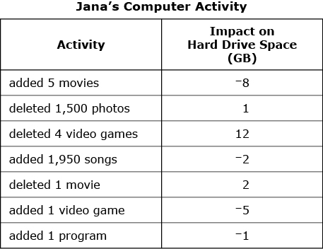
Explain the meaning of in this situation. (HINT: Lost 2 Gigabytes)
Explain the meaning of 12 in this situation. ______________________________________
Explain the meaning of 0 in this situation. __________________________________________
Part C
Jana said has a greater impact on the hard drive space than Is Jana’s statement correct? Explain your answer.
Part D
Using the symbols compare and .

Close
Close

