Learning Task: Graphing on the Coordinate Plane.

Number lines can be used to show numbers and their opposites. Both 3 and $-3$ are 3 units from zero on the number line. Graphing points and reflecting across zero on the number line extends to graphing and reflecting points across the x-axes (horizontal number line) or the y-axis (vertical number line) on a coordinate plane.

1. On the horizontal number line, plot 7 and $-7$. What is the distance of each point from zero? What is the distance between 7 and $-7$?

2. On the horizontal number line, plot 5 and $-5$. What is the distance of each point from zero? What is the distance between 5 and $-5$?

3. On the horizontal number line, plot 2 and $-2$. What is the distance of each point from zero? What is the distance between 2 and $-2$?

4. On the vertical number line, plot 1 and $-1$. What is the distance of each point from zero? What is the distance between 1 and $-1$?
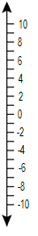

5. On the vertical number line, plot 10 and $-10$. What is the distance of each point from zero? What is the distance between 10 and $-10$?

6. On the vertical number line, plot 8 and $-8$. What is the distance of each point from zero? What is the distance between 8 and $-8$?

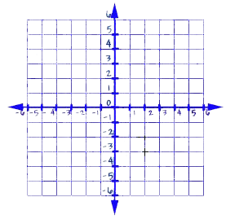
7. The points (1, 3), (-1, 5), (-3, 3), and (4, -4) have been graphed on the coordinate plane. Reflect each point across the x-axis. What are the coordinates of the reflected points?

When the star (1, 3) is reflected across the x-axis, the new point is located at _____.

When the triangle (-1, 5) is reflected across the x-axis, the new point is located at _____.

When the smiley face (-3, 3) is reflected across the x-axis, the new point is located at _____.

When the lightning bolt (4, -4) is reflected across the x-axis, the new point is located at _____.

What similarities do you notice between the coordinates of the original point and the reflected point?

8. The points (1, 3), (-1, 5), (-3, 3), and (4, -4) have been graphed on the coordinate plane. Reflect each point across the y-axis. What are the coordinates of the reflected points?

When the star (1, 3) is reflected across the y-axis, the new point is located at _____.

When the triangle (-1, 5) is reflected across the y-axis, the new point is located at _____.

When the smiley face (-3, 3) is reflected across the y-axis, the new point is located at _____.

When the lightning bolt (4, -4) is reflected across the y-axis, the new point is located at _____.

What similarities do you notice between the coordinates of the original point and the reflected point?’

Use the drawing of the city to help you answer questions 11-17.

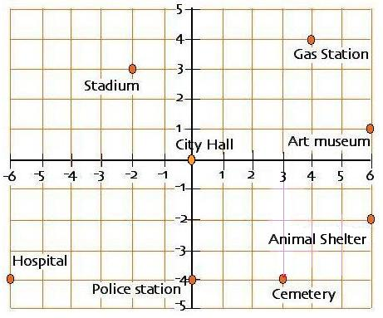

11. What is the location of city hall? What is the location of the police station? How many blocks apart are these two buildings?

12. What is the location of the art museum? What is the location of the animal shelter? How many blocks apart are these two buildings?

13. What is the location of the hospital? What is the location of the cemetery? How many blocks apart are these two buildings?

14. What is the location of the hospital? What is the location of the police station? How many blocks apart are these two buildings?

