Problem Solving with GCF and LCM

Always remember:
_____________ is on the ______________

AND

____________ is all of ________________
when using the sled/slide method!

TIP #1 – Look for KEY words that will tell you if you’re finding GCF or LCM!

For GCF: | For LCM:
TIP #2 – Draw a picture! Sometimes visualizing the problem will help it to make more sense!
Example 1: Johnny is making goodie bags that include a lollipop and bubbles. If the lollipops come 4 to a pack, and
the bubbles come 6 to a pack, what is the smallest number of bags that he can make and not have anything left over?
How many packs of lollipops and bubbles should he buy?
1 pack 2 packs 3 packs
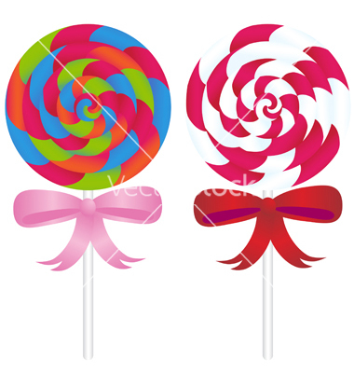 The is “smallest”, so you’re finding LCM.

Draw 4 lollipops and 6 bubbles until there is
nothing “left over”.

Answer:
The smallest number of bags w/o leftovers = 12
1 pack 2 packs He needs 3 packs of lollipops and 2 packs of bubbles.

Example 2: Shannon is making identical balloon arrangements for a party. She has 24 white balloons and 16 blue balloons. She wants each arrangement to have the same number of each color. What is the greatest number of arrangements that she can make if every balloon is used?
WWWBB WWWBB WWWBB WWWBB The is “greatest”, so you’re finding GCF.
WWWBB WWWBB WWWBB WWWBB Draw the balloons in the largest possible number
of equal groups.
Answer: She can make 8 balloon arrangements.

Try solving the following problems using GCF and LCM. Circle the , and SHOW ALL WORK!!

1) There are 40 girls and 32 boys who want to participate in 6th grade intramurals. If each team must have the same
number of girls and the same number of boys, what is the greatest number of teams that can participate in intramurals?
How many girls and boys will be on each team?

# teams = _______
# girls per team = ______
# boys per team = ______

2) Fred is making some hot dogs for his company picnic. Buns come 12 to a pack, and hot dogs come 8
to a pack. What is the fewest number of hot dogs he can make and not have any leftover buns or hot
dogs? How many packs of buns and packs of hot dogs should he buy?

# hot dogs he can make = _______
# packs of buns to buy = ________
# packs of hot dogs to buy = _______

3) Joe Bob is making a garden of 36 tomato plants and 45 corn plants. He wants to plant the same number
and type of veggie in each row. What is the maximum number of veggie plants Joe Bob can plant per row? How
many rows of tomato plants will he have? How many rows of corn plants?

# plants per row = ________
# rows of tomato plants = _______
# rows of corn plants = ________

4) At Moby’s Movies grand opening, every 8th customer will receive a free drink and every 10th person will
receive a free movie rental. What number customer will be the first to receive both free gifts?

# customer to receive both freebies = ________

5) Davyon has a collection of baseball cards that he wants to divide evenly into his albums. He has 36 Braves
cards, 30 Yankee cards, and 48 Cubs cards. What is the greatest number of albums he can use? How many Braves
cards, Yankee cards, and Cubs cards will be in each album?

# albums = ________
# Braves cards per album = _______
# Yankees cards per album = ________
# Cubs cards per album = _________

6) Three pigs entered a race around a track. Piggly takes 6 minutes to run one lap. Piglet takes 3 minutes to run one lap
and Wiggly takes 5 minutes to run a lap. If all three pigs begin the race at the same time, what is the shortest amount of
minutes it will take for all three pigs to be back at the starting line? How many laps will each pig have made at that time?

Time for all 3 pigs to be at starting point = ________
# laps for Piggly = ________
# laps for Piglet = ________
# laps for Wiggly = ________

