Let’s !!

When you simplify a fraction, you are writing it in lowest terms. The original fraction and the simplified fraction are equal.

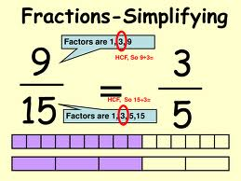

**GCF,**

**GCF,**

******************************************************

Tip: The fastest way to simplify a fraction is to divide by the GCF!

Example: Simplify 

Using any common factor:

5 is a common factor of 25 & 50…. But 5/10 is not completely simplified, so divide again…

 

Using the GCF:

25 is the GCF of 25 and 50…



Let’s !!

When you simplify a fraction, you are writing it in lowest terms. The original fraction and the simplified fraction are equal.



******************************************************

Tip: The fastest way to simplify a fraction is to divide by the GCF!

Example: Simplify 

Using any common factor:

5 is a common factor of 25 & 50…. But 5/10 is not completely simplified, so divide again…

 

Using the GCF:

25 is the GCF of 25 and 50…

