Equivalent Fractions

Equivalent fractions name the same amount!!

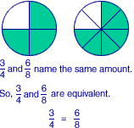

Equivalent fractions can be found by multiplying or dividing the numerator and the denominator by the same number.

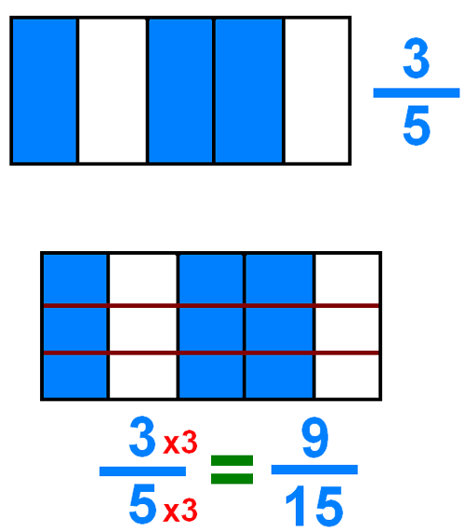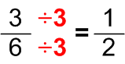Examples:

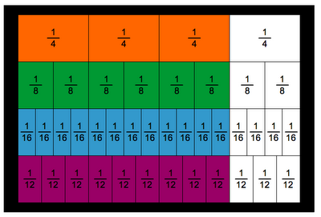

Look at the picture. Notice:



Equivalent Fractions

Equivalent fractions name the same amount!!



Equivalent fractions can be found by multiplying or dividing the numerator and the denominator by the same number.

Examples:



Look at the picture. Notice:

