Dividing Fractions
**Dividing by a number is the same as multiplying by its reciprocal!!**
Steps:
- Rewrite any mixed numbers as improper fractions (if necessary) | (No improper fractions in this problem!)
- Multiply by the reciprocal | =
- Simplify your answer if needed.

An example with mixed numbers:
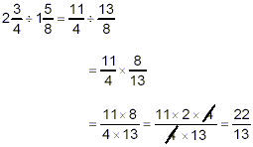
**Do not forget to change mixed numbers before you multiply by the reciprocal**
Example:

Dividing Fractions
**Dividing by a number is the same as multiplying by its reciprocal!!**
Steps:
- Rewrite any mixed numbers as improper fractions (if necessary) | (No improper fractions in this problem!)
- Multiply by the reciprocal | =
- Simplify your answer if needed.

An example with mixed numbers:
**Do not forget to change mixed numbers before you multiply by the reciprocal**
Example:

Dividing Fractions
** Remember that when you divide two numbers, you are finding out how many times the divisor fits into the dividend.
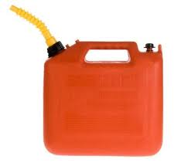
David’s lawn mower holds ¾ gallon of gas. If he has 1 ½ gallons of gas, how many times can he fill up his lawn mower?
3
4
3
4
You Try!
$$\frac{5}{6}÷\frac{5}{12}$$ | $$\frac{9}{10}÷\frac{3}{5}$$ | $$2\frac{1}{4}÷\frac{1}{8}$$
So, how many ¾’s will fit inside 1 ½ ?
$1\frac{1}{2}$ ÷ $\frac{3}{4}$
$\frac{3}{2}$ ÷ $\frac{3}{4}$
$\frac{3}{2}$ x $\frac{4}{3}$
$\frac{12}{6}$ = 2
¾ fits inside 1 ½ two times. David can fill up his lawn mower twice.

Dividing Fractions
** Remember that when you divide two numbers, you are finding out how many times the divisor fits into the dividend.
David’s lawn mower holds ¾ gallon of gas. If he has 1 ½ gallons of gas, how many times can he fill up his lawn mower?
3
4
3
4
You Try!
$$\frac{5}{6}÷\frac{5}{12}$$ | $$\frac{9}{10}÷\frac{3}{5}$$ | $$2\frac{1}{4}÷\frac{1}{8}$$
So, how many ¾’s will fit inside 1 ½ ?
$1\frac{1}{2}$ ÷ $\frac{3}{4}$
$\frac{3}{2}$ ÷ $\frac{3}{4}$
$\frac{3}{2}$ x $\frac{4}{3}$
$\frac{12}{6}$ = 2
¾ fits inside 1 ½ two times. David can fill up his lawn mower twice.

