~ Long Division ~
The Vocabulary: Example:
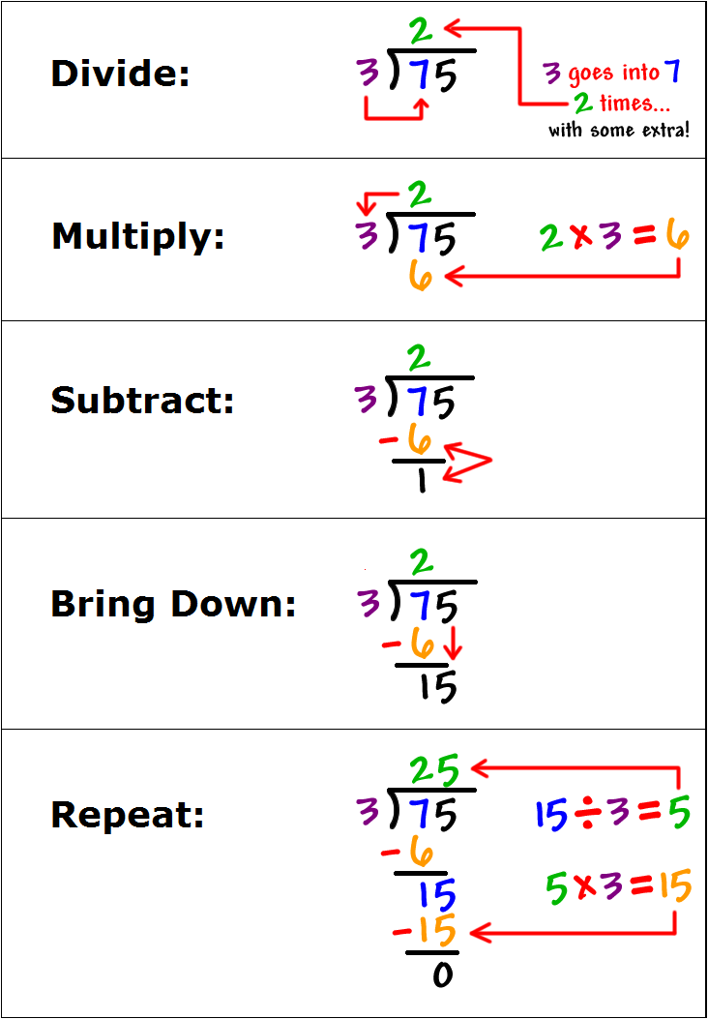
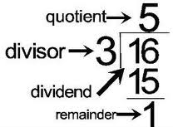
.3
.

- 9
* If the remainder is not zero, add a decimal and a zero to the dividend. Divide until the remainder is zero or the decimal repeats.
1
- The purpose of division is
to determine how many
times the divisor fits into
the dividend

- Division is the opposite of
multiplication. To “undo” or check your
answer, you can multiply it by the
divisor!

Now YOU Try!!

1) 6915 ÷ 15 2) 30 57,900 3) Scarlett has $18.75 to
purchase goody bags for
her party. If each bag
costs $1.25, how many
can she buy?

~ Long Division ~
The Vocabulary: Example:
.3
.

- 9
* If the remainder is not zero, add a decimal and a zero to the dividend. Divide until the remainder is zero or the decimal repeats.
1
- The purpose of division is
to determine how many
times the divisor fits into
the dividend

- Division is the opposite of
multiplication. To “undo” or check your
answer, you can multiply it by the
divisor!

Now YOU Try!!

1) 6915 ÷ 15 2) 30 57,900 3) Scarlett has $18.75 to
purchase goody bags for
her party. If each bag
costs $1.25, how many
can she buy?

