Name

Problem Solving: The Coordinate Plane

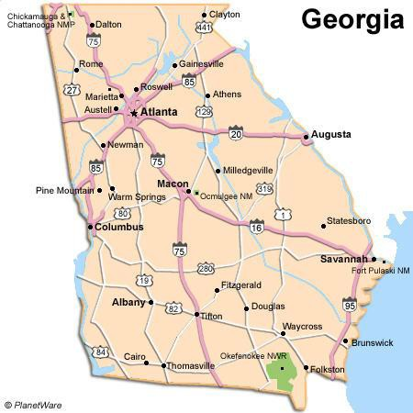Use the coordinate plane on the map of Georgia below to answer each question.

6

5

4

3

2

1

-6 -5

-4 -3 -2 -1
0
1 2 3
-1

4 5 6

-2

-3

-4

-5

-6

1. Which location in Georgia is closest to the ordered pair (1, 3)?

2. What ordered pair best describes the location of Rome, Georgia?

3. Which location in Georgia is closest to the ordered pair (0, 3)?

4. Name a city in Georgia that is located in Quadrant III.

5. Name a city in Georgia with an x-coordinate of approximately 3.

6. Name two cities in Georgia in which the y-coordinates are less than 4. _,

