

Distance Between Points on a Coordinate Plane

When two ordered pairs have the same x-coordinate or y-coordinate, they are on the same line.

The distance between these two points can be found by **counting the spaces** between the points.



Points A and B have the same second coordinate. The distance between them is 5 units.

Point A = (-3,3)

Point B = (2,3)

Point C = (-3,4)

Point A is 5 units from Point B. Likewise, B is 5 units from A. We wouldn’t say that they are -5 units away, even though you may move to the left on the number line, because distance is ALWAYS positive. For example, if you traveled 5 blocks to school and forgot your lunch and had to go back for it, you would have traveled another 5 blocks for 10 round trip. In other words, absolute value is always used to calculate distance!

Points A and C have the same first coordinate. The distance between them is 7 units.

You can also use **absolute value** to determine the distance between points!

* Notice Point A = (-3,3) and Point B = (2,3). They have the same y-coordinate, ______.
* That means you’re finding the distance between the x-coordinates, _____ and _____.
* -3 is 3 units from the y-axis, or |-3| = _____
* 2 is 2 units from the y-axis, or |2| = _____
* |-3| + |2| = _______ units

**Example**: (2,9) and (2,3) have the same x-coordinate. **Example**: Area of a triangle = 1/2(b • h).

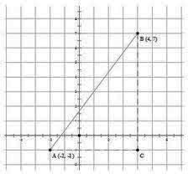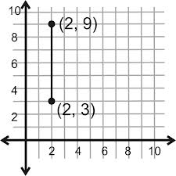 The distance between base = dist from A to C =

them is 6 units. You _______ units

can figure this out by height= dist from B to C =

_______ units

___________________

Area of Δ ABC =

___________________

___________________

[](http://www.google.com/imgres?hl=en&tbo=d&biw=1600&bih=697&tbm=isch&tbnid=Szsr1hd58YeHEM:&imgrefurl=http://www.heritagepreservation.org/cap/ReCAP.html&docid=Sv8MvY9ODOPE7M&imgurl=http://www.heritagepreservation.org/cap/images/revisedRECAP.png&w=392&h=294&ei=VQfmUKv_EMPw2QXw1IEY&zoom=1&iact=hc&vpx=828&vpy=162&dur=250&hovh=194&hovw=259&tx=115&ty=95&sig=118279028075191188497&page=1&tbnh=141&tbnw=188&start=0&ndsp=34&ved=1t:429,r:5,s:0,i:130)

(1) Count the spaces between the points!

--- OR ---

(2) Use absolute value to add the different coordinates!

There are 2 WAYS to find the distance between two points…

[](http://www.google.com/imgres?start=299&hl=en&tbo=d&biw=1600&bih=697&tbm=isch&tbnid=cNTmSpHcLFsqGM:&imgrefurl=https://signorakudron.wikispaces.com/&docid=RsfNjtPixlif8M&imgurl=http://image.yaymicro.com/rz_1210x1210/0/bd1/practice-makes-perfect-bd127f.jpg&w=1210&h=807&ei=lBDmUL71MYLm8gTk8oCIAw&zoom=1&iact=hc&vpx=168&vpy=151&dur=2590&hovh=183&hovw=275&tx=131&ty=109&sig=118279028075191188497&page=8&tbnh=139&tbnw=218&ndsp=42&ved=1t:429,r:8,s:300,i:28)

Distance Between Points

on a Coordinate Plane

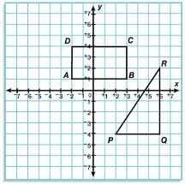

**PRACTICE PART 1:**

1) Write the ***ordered pair*** next to each point on the graph 🡪

2) Determine the ***length of each side*** of the rectangle.

If you have room, you may also label them on the graph.

 = _________  = _________

 = _________  = _________

3) What is the ***perimeter*** of rectangle ABCD? ____________

4) What is the ***area*** of rectangle ABCD? ________________

5) Determine the length of the triangle’s base and height:  = _________  = _________

6) What is the ***area*** of ΔPQR? _________________

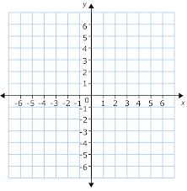

**PRACTICE PART 2:**

Bugs Bunny’s home is located at Point B, (-5, 4).

Yosemite Sam’s home is located at Point Y, (6, 4).

Sylvester’s home is located at Point S, (6, -2).

Daffy Duck’s home is located at Point D, (-5,-2).

7) Plot each character’s home on the graph. 🡪

Connect them in the order they are listed (also connect

B & D). Label them B, Y, S, and D, as noted above.

8) What polygon was made? _________________________

9) Find the distance from each house (length of sides):

 = _________  = _________

  = _________  = _________

10) If they march in a parade that begins at Bugs’ house,

goes around the rectangle, and ends at Bugs’ house,

how many units did they travel?