Skills Practice

The Coordinate Plane
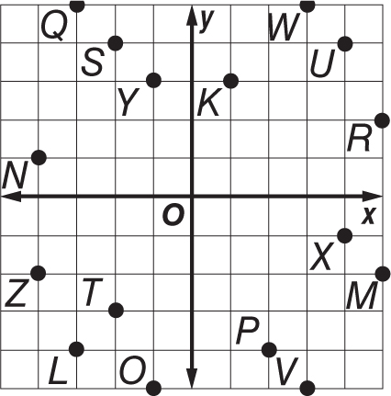

Use the coordinate plane at the right. Identify the point for each
ordered pair.

1. (–2, 4) 2. (–2, –3)

3. (4, 4) 4. ( 3, –5)

5. (3, 5) 6. ( 4, –1)

7. (–1, 3) 8. (–4, –2)

Use the coordinate plane above. Write the ordered pair that names
each point. Then identify the quadrant where each point is located.

9. K 10. L

11. M 12. N

13. 0 14. P

15. Q 16. R

Identify the quadrant where each point is located.

17. (–5, 2) 18. (2, 1)

19. (1, –3) 20. (–5, –1)

21. (3, 3) 22. (–1, 2)

23. (1, –1) 24. (2, –5)

25. (3, –2) 26. (–4, –5)

27. (1, 5) 28. (–2, 5)

29. (–1, –4) 30. (5, –5)

