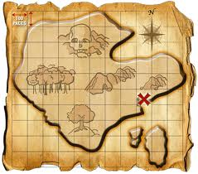
Coordinate Plane

- The Coordinate Plane is a grid consisting of two perpendicular number lines, the (horizontal) x-axis and (vertical) y-axis
- The axes intersect at point (0,0), also known as the “origin”
- The four open areas are called “quadrants”
- Points can be plotted on the plane using a pair of x- and y- coordinates called “ordered pairs”.
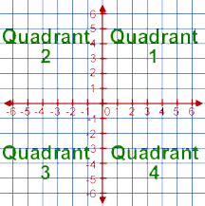
y

(-, +) (+, +) x
Point (0,0) is called
the “origin”.

(-, -) (+, -)
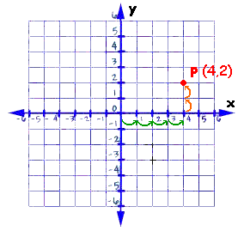
How do I Plot Points??
ALL ordered pairs are written as (x,y). (-2, 4)
The 1st number tells how far to go ACROSS on the X-axis
The 2nd number tells how far to go UP OR DOWN the Y-axis.
(-5, -2)
(1, -3)

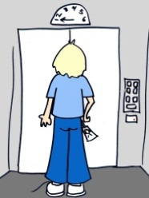

Remember: You have to walk in the building before going up or down the elevator!
(In other words, go ACROSS the x-axis with the 1st number, then UP OR DOWN with the 2nd number!)

Coordinate Plane Practice

PART 1:
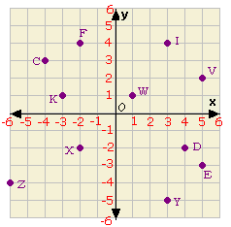
Write the ordered pair for each point in the
plane to the left. For instance, C = (-4,3).

D =_______________ V = ________________

E = ______________ W =________________

F = ______________ X = ________________

I = _______________ Y = ________________

K =_______________ Z = _________________

PART 2:
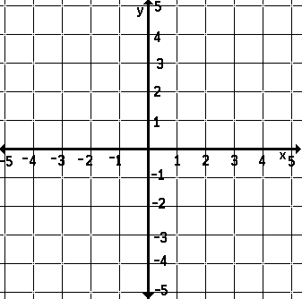
Plot these points on the coordinate
plane below. Be sure to label the letter next to each point.

C (0,0) H (4,3)
O (-2,-1) R (-4,0)
A (-2,3) K (3,-1)

M (-4,5) T (0,4)

S (4,-3)

What “secret message” do you see?
_______________ __________________

